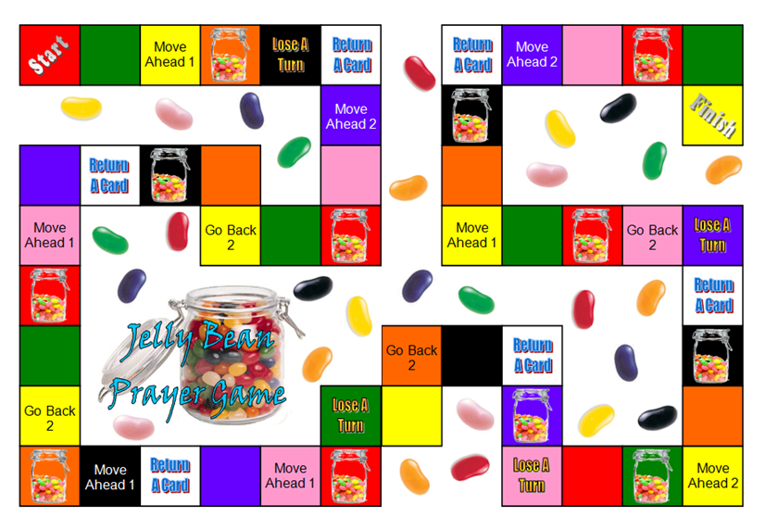
Return a Jelly Bean
Return a Jelly Bean
Return a Jelly Bean
Return a Jelly Bean
Return a Jelly Bean
Return a Jelly Bean

Question: How many times did Peter deny Jesus?  Answer: Three times | Question: Who told the women at the tomb that Jesus was alive?  Answer: Angel | Question: Why were women going to Jesus’ tomb?  Answer: To anoint his body with spices
Question: Which two disciples ran to the tomb when the women told them Jesus was not inside?  Answer: Peter and John | Question: Who was the first person to see Jesus alive on Easter Sunday?  Answer: Mary Magdalene | Question: When Jesus spoke to Mary in the garden on Easter Sunday, who did Mary think he was at first?  Answer: The Gardener
Question: How many silver coins did the priests give to Judas for betraying Jesus?  Answer: 30 silver coins | Question: During the Last Supper when Jesus broke the bread, what did He say it represented?  Answer: His body broken for us. | Question: During the Last Supper when Jesus took the cup of whine, what did He say it represented?  Answer: His blood poured out for us.
Question: Why do we do communion?  Answer: In remembrance of Jesus’ crucifixion | Question: When the people welcomed Jesus into Jerusalem on Palm Sunday what did they shout?  Answer: “Hosanna!” | Question: What does “Hosanna” mean?  Answer: “Save us!”
Question: What ruler allowed Jesus to be crucified?  Answer: Pontius Pilot | Question: Who cut off the ear of one of the guards trying to arrest Jesus?  Answer: Peter | Question: Who were the two men crucified with Jesus?  Answer: Thieves
Question: What animal did Jesus ride on when coming into Jerusalem?  Answer: Donkey | Question: How many days was Jesus in the tomb?  Answer: Three days | Question: What cruel things did they do to Jesus before he was crucified?  Answer: Whipped him, placed a crown of thorns on his head, taunted him, punched him, spat on him, etc.
Question: Why did Jesus die on the cross?  Answer: Jesus died on the cross to take the punishment for our sins. | Question: While dying on the cross, who did Jesus ask to take care of his mother?  Answer: John | Question: What were the disciples doing in the Garden of Gethsemane that disappointed Jesus?  Answer: Sleeping
Question: What did Pilate do to show that he did not want to be associated with Jesus?  Answer: Washed his hands | Question: Pilate asked the people “What should I do with Jesus?” What did the people say?  Answer: “Crucify him!” | Question: Who did the people choose to be set free instead of Jesus?  Answer: Barnabas
Question: Who helped Jesus carry the cross?  Answer: Simon | Question: What did the soldier do to make sure Jesus was dead?  Answer: He thrust a spear into Jesus’ side. | Question: Who asked Pilate if he could bury Jesus’ body?  Answer: Joseph of Arimathea
Question: How many hours did it take for Jesus to die on the cross?  Answer: Three | Question: Jesus was celebrating what holiday with his friends during the Last Supper?  Answer: Passover | Question: What is Passover?  Answer: Passover is a week-long holiday when God’s people remember how HE helped them escape from slavery in Egypt.
Question: What did the Pharisees do to ensure Jesus’ body would not be stolen from the tomb?  Answer: They rolled a huge stone in front of the tombs and soldiers guarded the tomb. | Question: Where did Jesus pray that night he was arrested?  Answer: Garden of Gethsemane | Question: What two things did God send just before sunset on the third day Jesus was in the tomb?  Answer: Earthquake and an angel to roll away the stone in front of the tomb
Question: Why do we celebrate Easter Sunday?  Answer: We celebrate Easter Sunday to remember Jesus death and resurrection. | Question: What is the name of the hill on which Jesus was crucified?  Answer: The Scull | Question: What did Jesus mean when he said “It is finished” before he died?  Answer: Jesus meant that he had fulfilled God’s plan for Jesus to die on the cross to take the punishment for man’s sin.
Jelly Bean Prayer Game: The objective of the game is to collect the most Jelly Beans by answering questions about the Easter story and getting to the Finish.
Every time you land on a Jelly Bean jar space, you receive ONE Jelly Bean.
Every time you land on a blank color space you are read a “Jelly Bean” card question. If you answer the question correctly, you receive TWO Jelly Beans.
The first person to land on the Finish space receives FIVE Jelly Beans.
Once a player lands on the Finish space and receives his prize, the game is over and the players count their Jelly Beans. The player with the most Jelly Beans wins!

