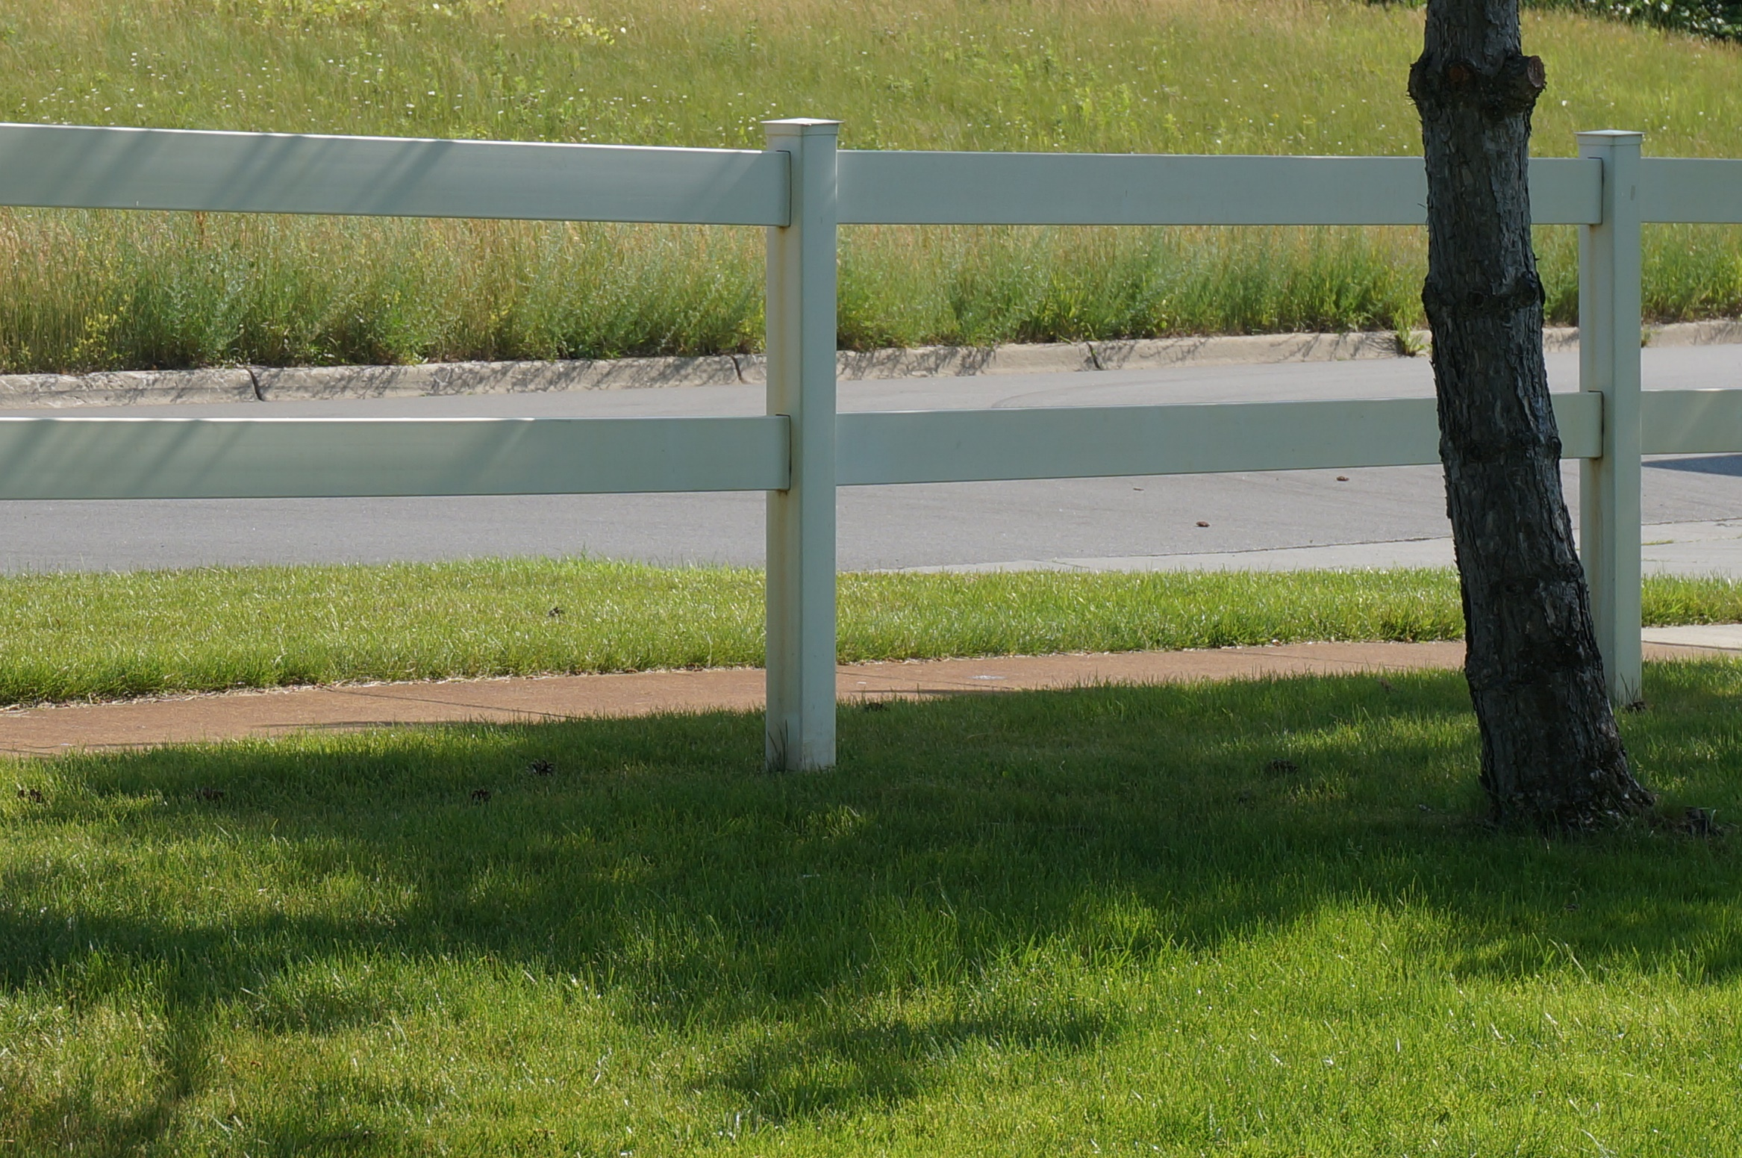

**July 18 – 22, 2016**

**Monday – Friday**

**10:00 a.m. – 11:30 a.m.**

**Cost: Free!**

**In the backyard of**

**Greg & Rachel Vruggink**

**Clearpoint Valley Townhouse 183**

**(616) 690-9349**

Backyard Bible Club

For kids ages 4-12

Bible Lessons Games Snacks

Songs Friends Crafts

------------------------------------------------------------------------------------------------------------------------------------------------------------------------------------------------------------

If you plan to attend please let us know by returning this slip to Greg & Rachel Vruggink - Townhouse 183

Child’s Name #1: ______________________________________________ Child’s Age #1: _____________

Child’s Name #2: ______________________________________________ Child’s Age #2: _____________

Child’s Name #3: ______________________________________________ Child’s Age #3: _____________

Parent/Guardian Name: _______________________________________ Parent/Guardian Cell Phone: _______________________________

Parent/Guardian Email: _______________________________________